Phase 5 (Lite) Report — Centralized Logging with Syslog (pfSense → Ubuntu)
Date: 2025-12-21

1. Objective
This phase centralizes pfSense logs on the Ubuntu DMZ server using syslog (UDP/514). Centralization makes it easy to investigate access attempts and blocked traffic from a single location.

2. Topology
pfSense forwards logs to an Ubuntu syslog server in the DMZ. Kali generates a blocked test connection.
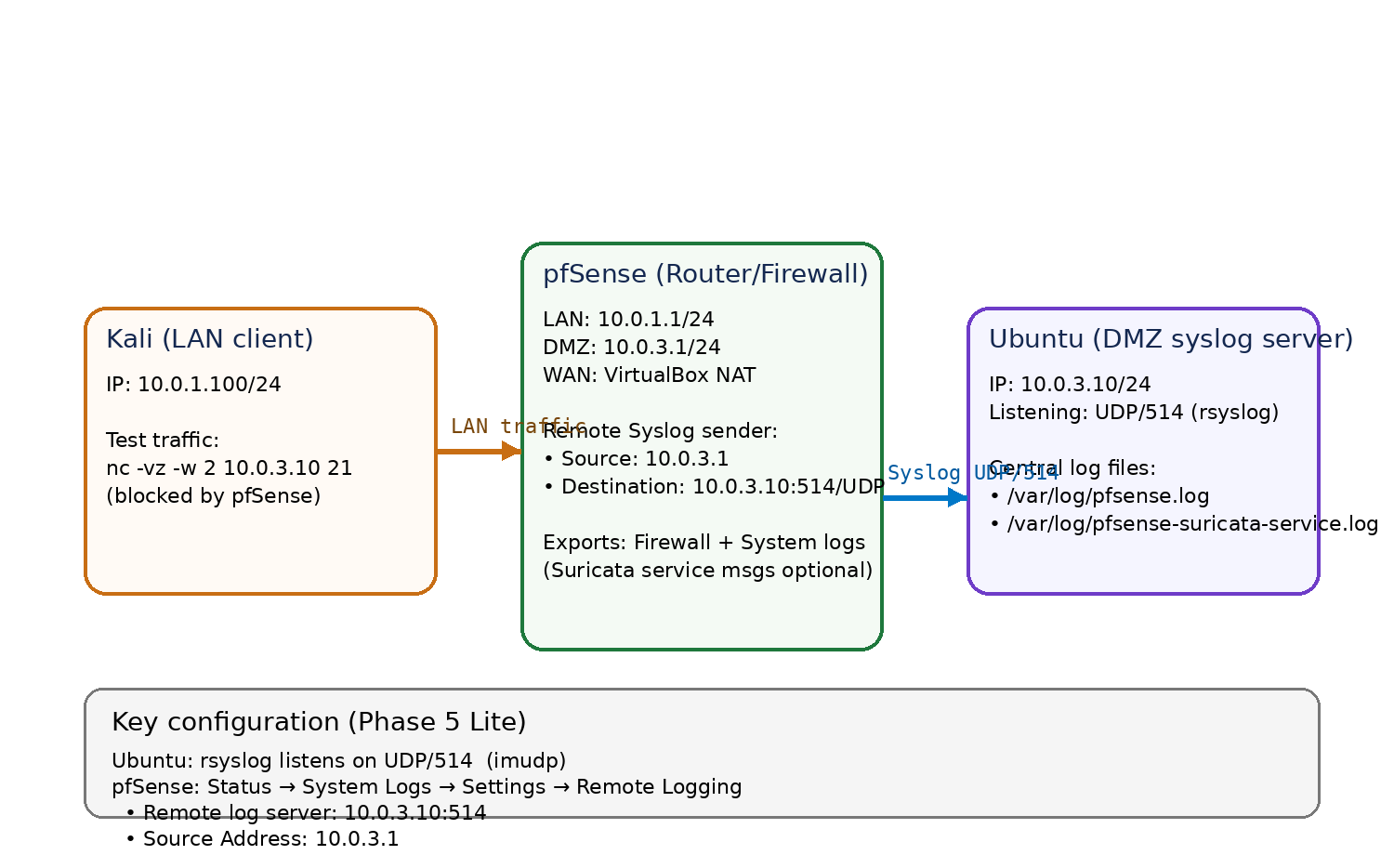
Figure 1. Syslog centralization topology (pfSense → Ubuntu).

3. Ubuntu Syslog Receiver
Ubuntu DMZ runs rsyslog and listens for remote syslog on UDP/514.
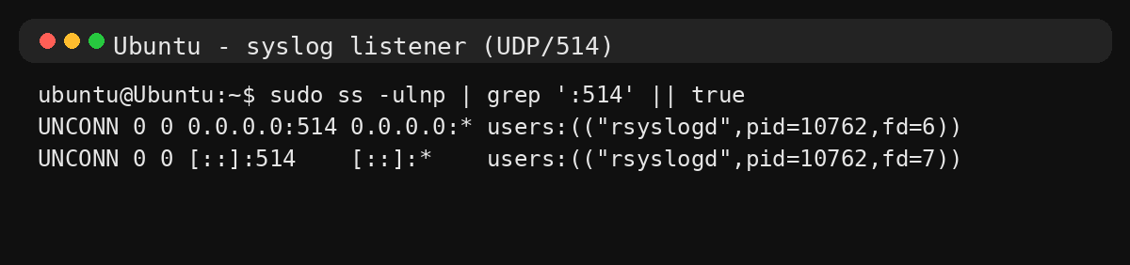
Figure 2. Ubuntu is listening on UDP/514 for syslog messages.

4. pfSense Remote Logging
Remote Logging was enabled on pfSense and configured to send logs to 10.0.3.10:514. Source Address was set to 10.0.3.1 (pfSense DMZ interface) to match the Ubuntu firewall rule.

5. Proof-of-Logging Test
A blocked FTP/21 attempt was generated from Kali and observed centrally on Ubuntu in /var/log/pfsense.log.
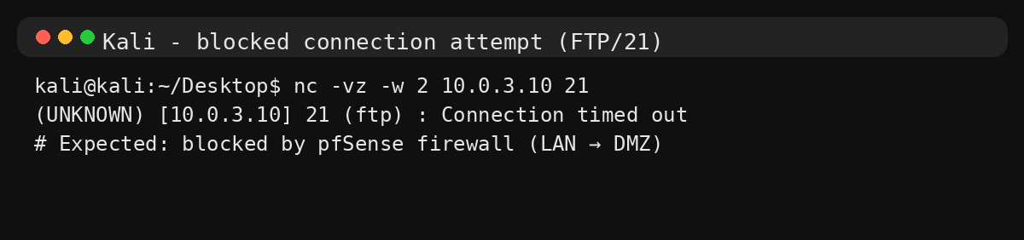
Figure 3. Kali generates a blocked TCP/21 connection attempt.
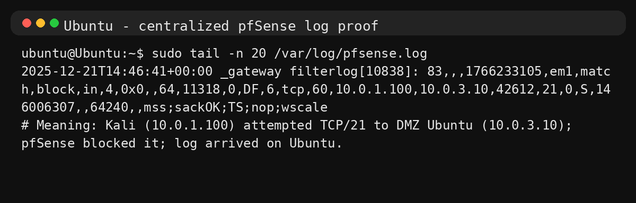
Figure 4. pfSense block event centralized on Ubuntu (filterlog entry).

6. Conclusion
Centralized logging is functioning correctly: pfSense firewall events are forwarded to Ubuntu and stored in a dedicated file. This provides a foundation for later phases (monitoring, alert correlation, and incident-style investigations).

